|  |  |  |
| --- | --- | --- |
| All in big endian |  |  |
| Command Name | Command Byte Value | Data for Command and Type |
| Drive | 0x2 | 2byte packed unsigned int |
| Turn | 0x1 | 2byte packed signed int |
| Toggle OA | 0x3 | functions off command byte value |
| Drive to destination | 0x5 | 4bytes unsigned int |

Pi to Tiva sent 0x0002 for user choice of motor/feature control

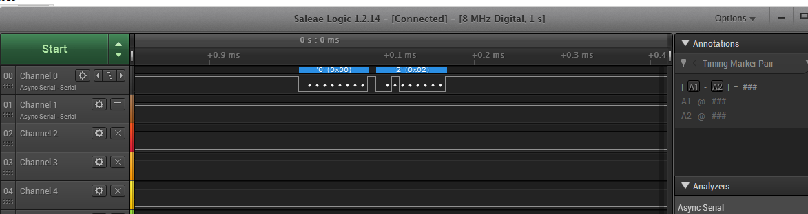

From the Tiva to the Pi sending 0x017A to indicate motor function ended

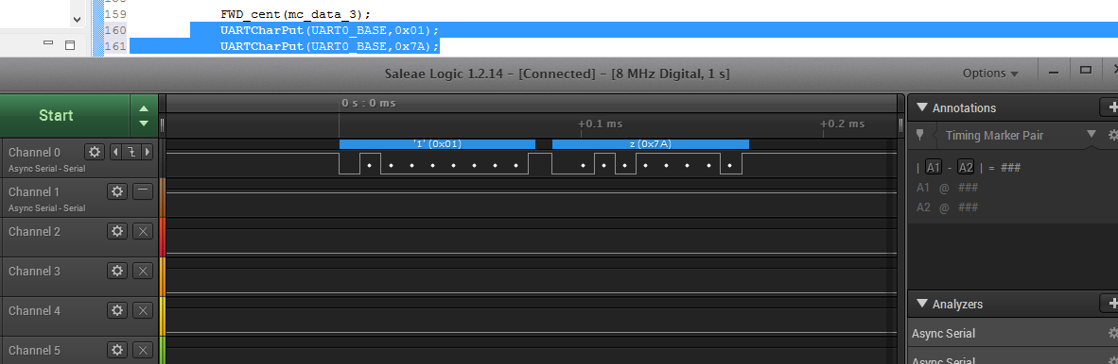

Start

Tiva

Receives

2Bytes

From Pi

Tiva waits for commands from Pi

Unable to

Perform

Action

Robot

Performs

Action

Action

Complete

Tiva send

2Bytes to Pi